User Guide - MOSAIC
1. Introduction
MOSAIC is a web-based system that generates a full-stack software project from an OPL specification. The system receives an OPL text or HTML file, stores the specification, activates an AI-based generation workflow, creates a React frontend and Flask backend, packages the result as a ZIP file, and displays evaluation scores for the generated output.
2. Guide Scope
This guide focuses on the successful operating flow of the system. It is intended for end users who generate projects from OPL specifications and for maintainers who need to understand the system structure, components, and upkeep responsibilities.
3. System Overview & Architecture
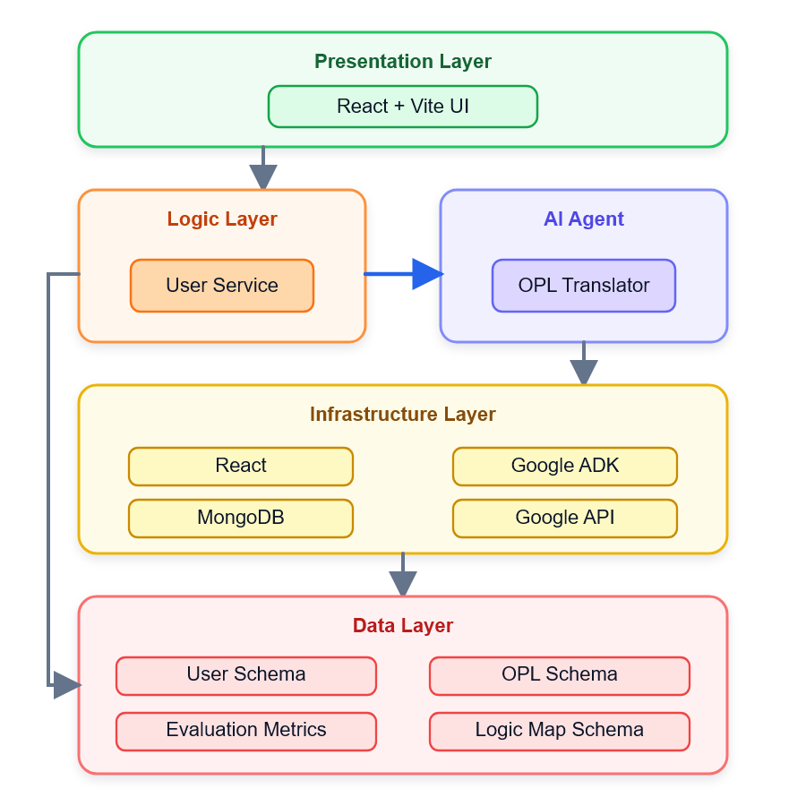
The system is organized around a simple user workflow: sign in, upload an OPL file, review and edit the extracted content, generate the project, download the ZIP file, and review the evaluation results.
- Frontend: React, Vite, Tailwind CSS, React Router, and Axios.
- Backend: Python, Flask, Flask-CORS, and PyMongo.
- Database: MongoDB for users, OPL files, generated results, and evaluation data.
- Agent workflow: Google ADK with Gemini and role-based instructions for Supervisor, Generator, and Critic behavior.
- Generated output: a ZIP package containing frontend/ and backend/ folders.

4. System Flow
The normal operating sequence starts with an authenticated user and ends with a generated ZIP file and evaluation results.
- The user signs in or registers.
- The user opens New Project and uploads a .txt or .html OPL file.
- The frontend reads the file and displays the extracted OPL text for review.
- The user confirms or edits the OPL content and clicks Generate.
- The backend saves the OPL in MongoDB and starts the agent workflow.
- The Supervisor loads the OPL and passes control to the Generator.
- The Generator creates frontend and backend project files and packages them into a ZIP file.
- The Critic evaluates graph coverage and syntax/execution readiness.
- The browser downloads the generated ZIP file and displays the evaluation scores.
- The user can navigate to “My Projects” tab and view his earlier projects.

5. Prerequisites

Requirement | Description
User account | The user must register or sign in before generating a project.
Supported input file | The application accepts .txt and .html files containing OPL content.
Browser | Use a modern browser such as Chrome, Edge, or Firefox.
Stable connection | Generation may take several minutes and requires the browser tab to remain open.
Generated project runtime | To run the downloaded project locally, Node.js/npm and Python/pip are required.

6. User Guide - Operating Instructions
This section describes the successful user flow through the MOSAIC interface. The system should be operated in the order shown below.
6.1 Account Access
Register a New Account
- Open the application and choose Sign up.
- Enter your full name, email address, and password.
- Click Create account.
- After successful registration, the system redirects you to the New Project page.
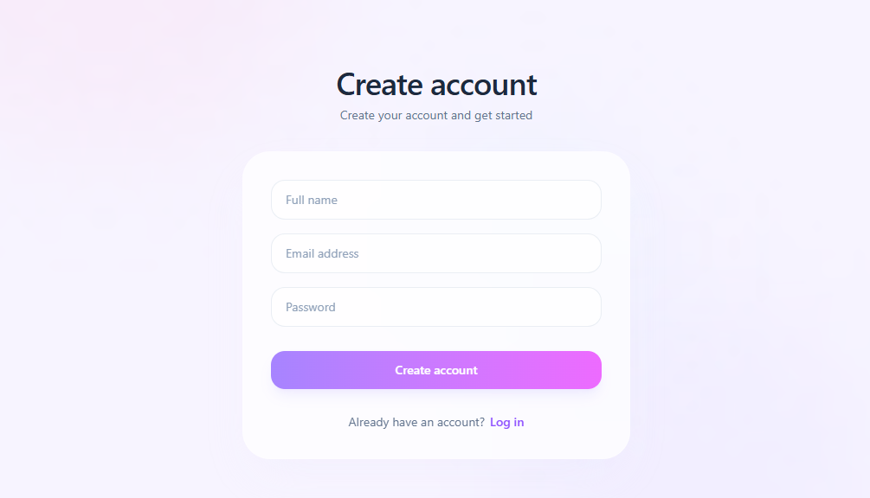
Figure 1 - Registration Page: Screenshot showing the Sign Up page with the name, email, and password fields.

Sign In
- Open the application login page.
- Enter your email address and password.
- Click Sign in.
- After successful login, the system redirects you to the New Project page.
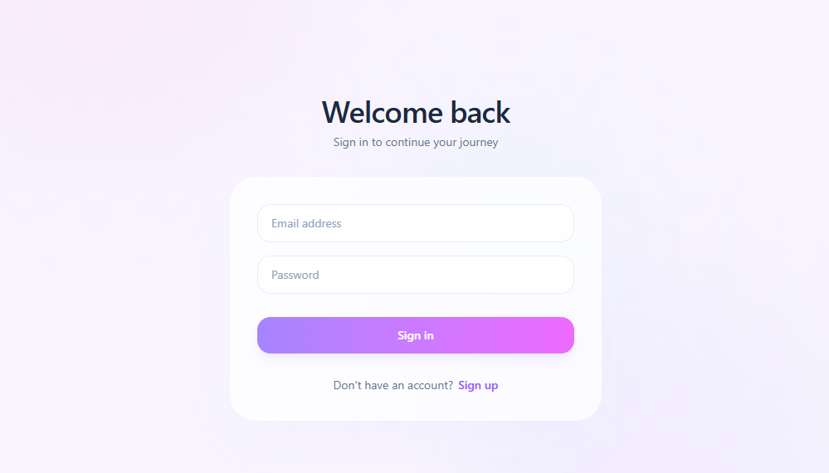
Figure 2 - Login Page: Screenshot showing the login page and sign-in fields.

6.2 Create a New Project
Upload an OPL File
- Go to the New Project page.
- Click the Upload File area or drag a file into the upload area.
- Select a .txt or .html file.
- Click Read & Convert.
- Wait until the upload process finishes and the OPL content appears on screen.
If an HTML file is uploaded, the system extracts the visible text content from the HTML body. If a text file is uploaded, the system reads the file directly as plain text.
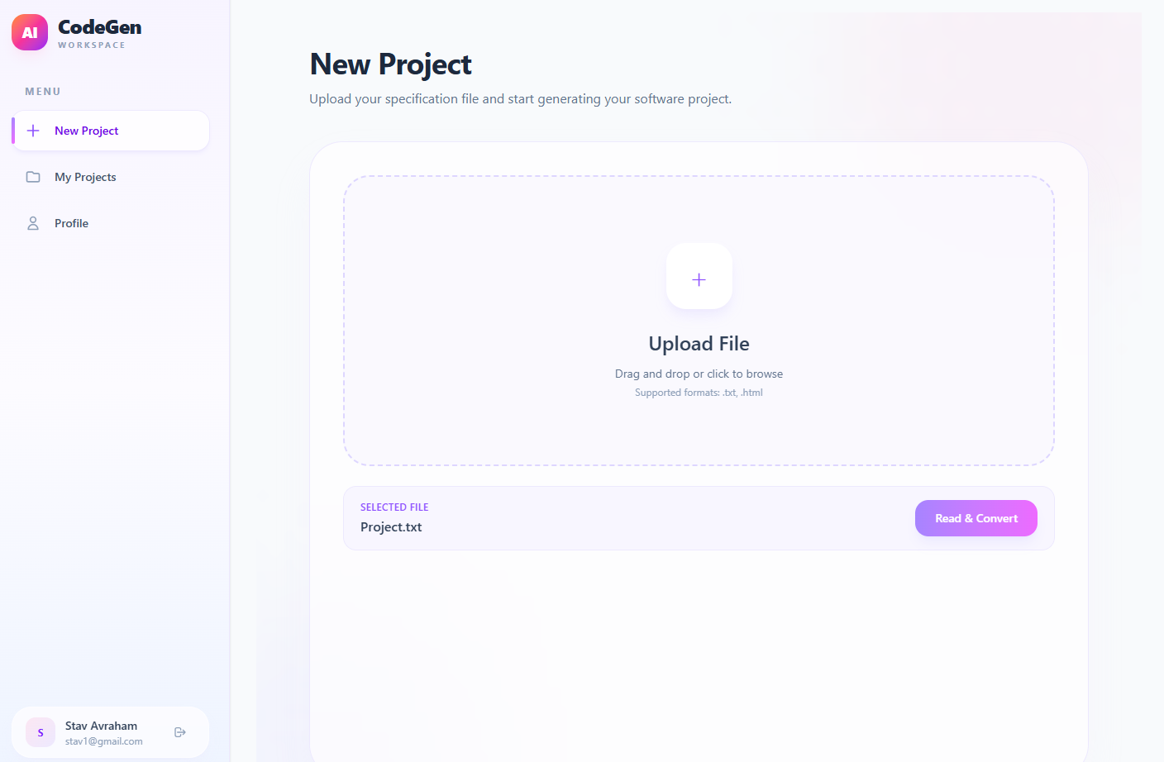
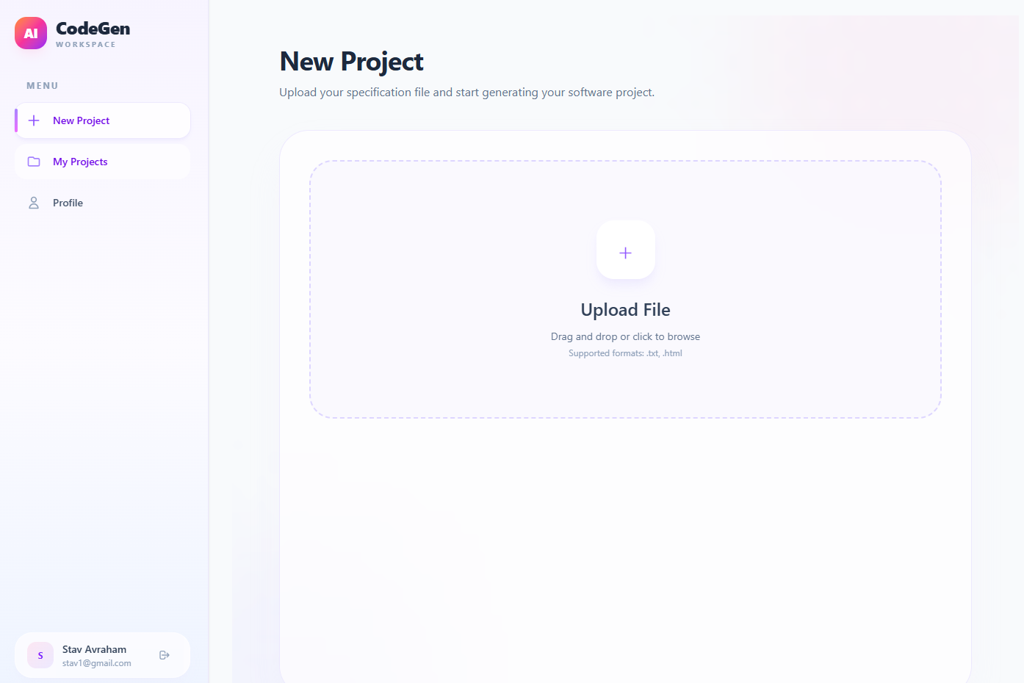
Figure 3 - New Project – File Upload: Screenshot showing the file upload area and the Read & Convert button.

Review and Edit the OPL Content
- Review the content shown in the OPL content text area.
- Edit the content if the extracted text is incomplete, inaccurate, or contains irrelevant text.
- Enter or adjust the file name if needed.
- Make sure the OPL content is not empty before continuing.
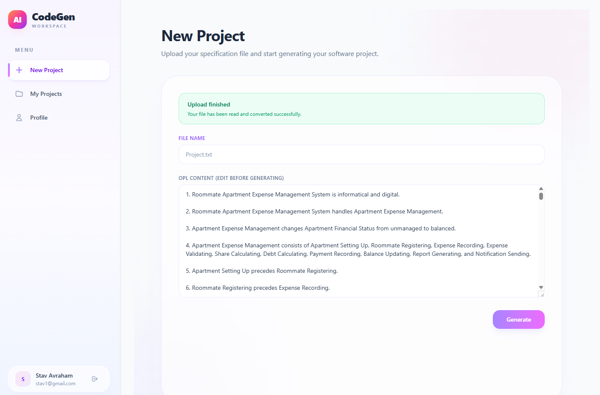
Figure 4 - OPL Content Review: Screenshot showing the file upload area, extracted OPL content, editable text area, and Generate button.

Generate the Project
- Click Generate.
- The system saves the OPL file and opens the Generate Project page.
- Keep the browser tab open while the agent runs.
- Follow the progress stages shown on screen.
- When generation finishes, the ZIP file downloads automatically.
6.3 Generation Progress
During generation, the interface displays progress stages so the user can understand the current status of the workflow. The agent may jump between stages 3 + 4, according to his decision.
 | Stage | Meaning
1 | Initializing agent | The system prepares the ADK/Gemini workflow.
2 | Loading OPL specification | The saved OPL input is loaded for processing.
3 | Generating frontend & backend | The Generator creates the React frontend and Flask backend.
4 | Running evaluation | The Critic evaluates graph coverage and execution readiness.
5 | Packaging project | The generated files are compressed into a downloadable ZIP file.

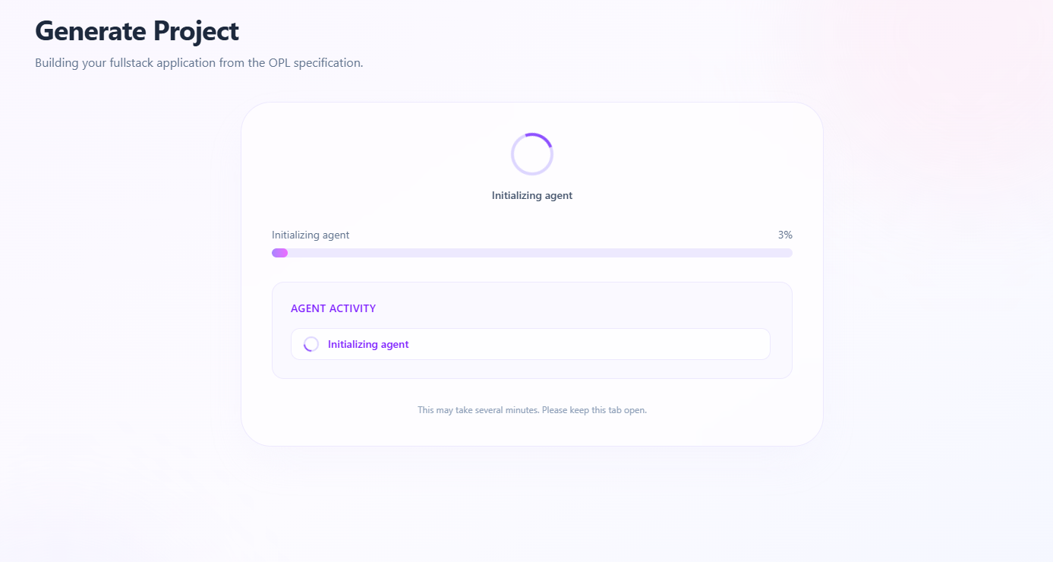
Figure 5 - Project Generation Progress: Screenshot showing the generation stages and the current workflow status.

6.4 Evaluation Results
After generation completes, the system attempts to retrieve and display evaluation results. These results help estimate whether the generated project is aligned with the OPL specification and whether the code is structurally ready to run.
Metric | Explanation
Overall | Weighted final score based on graph coverage and syntax/execution readiness.
Graph Coverage | Measures whether OPL entities, states, and relations are represented in the generated project graph.
Syntax | Checks whether generated Python, JavaScript, JSX, and JSON files are structurally valid.
Executability | Checks whether the generated project contains required files, Flask routes, CORS setup, Vite configuration, service/API wiring, and other static readiness indicators.
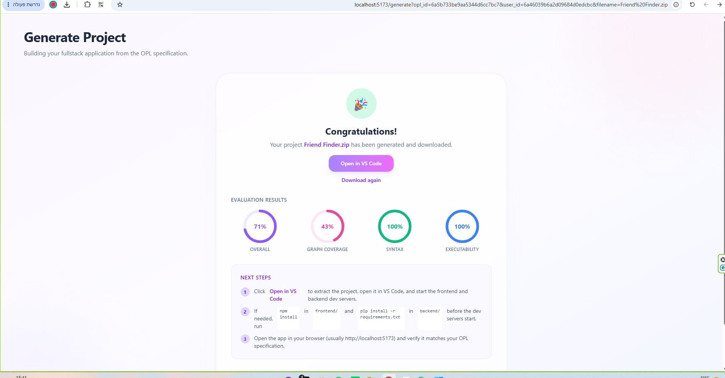
Figure 6 - Evaluation Results: Screenshot showing the Overall, Graph Coverage, Syntax, and Executability evaluation results.

6.5 Downloaded Project Structure
The generated ZIP file contains two main folders:
- frontend/ - the generated React/Vite user interface.
- backend/ - the generated Flask API and backend logic.

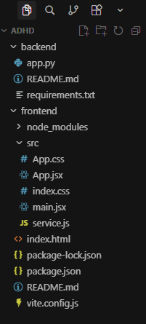
Figure 7 - Generated Project Structure: Screenshot showing the generated frontend/ and backend/ directories.

Run the Generated Backend
- Extract the downloaded ZIP file.
- Open a terminal in the backend/ folder.
- Run: pip install -r requirements.txt
- Run: python app.py
- Leave the backend terminal open while testing the application.
Run the Generated Frontend
- Open a second terminal in the frontend/ folder.
- Run: npm install
- Run: npm run dev
- Open the local URL shown in the terminal, usually http://localhost:5173.
- Test whether the generated application behaves according to the OPL specification.

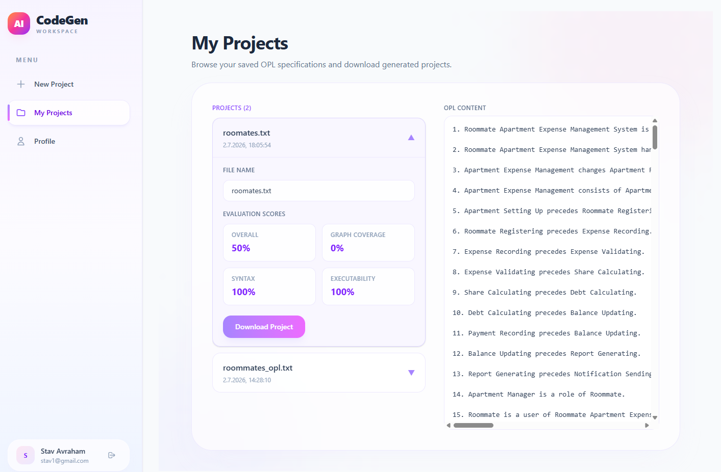
Figure 8 - User Generated Projects: Screenshot showing the all generations by user, with download and change name options.

7. User Interface Reference
Screen | Purpose | Main User Actions
Login | Authenticates existing users. | Enter email and password and sign in.
Register | Creates a new user account. | Enter full name, email, and password and create an account.
New Project | Receives and prepares the OPL specification for generation. | Upload .txt/.html file, read and convert, review/edit OPL content, and click Generate.
Generate Project | Runs the AI generation workflow and displays its progress and results. | Keep the tab open, monitor generation progress, review evaluation scores, and download the generated ZIP.
My Projects | Displays projects previously created by the user. | View and access previously generated projects.
Profile | Displays the current user's account information. | View stored name and email.

